Kynurenic Acid (KYNA) and Quinolinic Acid (QUIN) (2,3-pyridinedicaroxylic acid)
The most common causes of elevated kynurenic acid are the use of tryptophan supplements. Other causes may include vitamin B6 deficiency and high homocysteine concentrations. Increased homocysteine level can also cause heart diseases and sudden heart attack. Kynurenic acid levels are also important as a biomarker of chronic infection in the body. Increased kynurenic acid levels have been associated with Alzheimer's, Parkinson's and Huntington's diseases. The normal level of kynurenic acid is 0- 7.1 mmol/mol creatine.
One of the most important neuroactive intermediates of the kynurenine pathway is quinolinic acid (2,3-pyridinedicaroxylic acid). There is accumulating evidence that quinolinic acid is involved in neurotoxicity associated with several inflammatory brain diseases such as Alzheimer's, HIV-related neurocognitive disorders, Parkinson's disease, motor neuron disease, Huntington's disease, Multiple Sclerosis, and major psychiatric disorders. The normal level of quinolinic acid is 0- 5.8 mcg/mg creatinine.
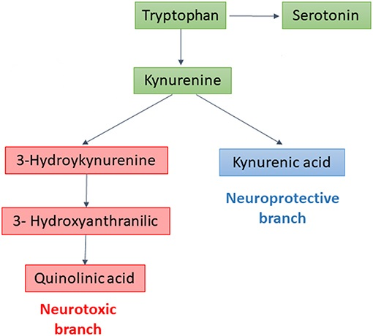

Colpo GD, Venna VR, McCullough LD, Teixeira AL. Systematic Review on the Involvement of the Kynurenine Pathway in Stroke: Pre-clinical and Clinical Evidence. Front Neurol. 2019 Jul 19;10:778. doi: 10.3389/fneur.2019.00778. PMID: 31379727; PMCID: PMC6659442.

Erabi H, Okada G, Shibasaki C, Setoyama D, Kang D, Takamura M, Yoshino A, Fuchikami M, Kurata A, Kato TA, Yamawaki S, Okamoto Y. Kynurenic acid is a potential overlapped biomarker between diagnosis and treatment response for depression from metabolome analysis. Sci Rep. 2020 Oct 8;10(1):16822. doi: 10.1038/s41598-020-73918-z. PMID: 33033336; PMCID: PMC7545168.
Ostapiuk A, Urbanska EM. Kynurenic acid in neurodegenerative disorders-unique neuroprotection or double-edged sword? CNS Neurosci Ther. 2022 Jan;28(1):19-35. doi: 10.1111/cns.13768. Epub 2021 Dec 3. PMID: 34862742; PMCID: PMC8673711.

